MEMORIES OF WORKING IN TOBACCO AS A TEEN
Two Summers, 1960 and 1961
By Jeanne Zembiski Fitzgerald

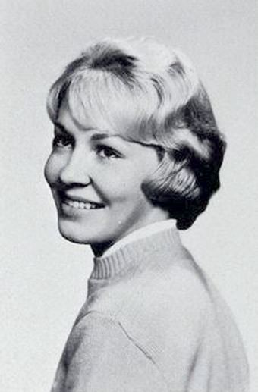
I wanted a job in the summertime and working in tobacco seemed to be the only thing there was to do to earn money, because I wasn’t keen on babysitting! I needed some spending money (usually for lipstick or nail polish) and some for “saving for college” as my parents always reminded me! Since my dad Tony Zembiski was already employed at the Billy Wilkes Division of Meyer and Mendelsohn Tobacco Company, a job in tobacco appeared to be the place to go.

I had to first get a Worker’s Permit at age 14 from the local town offices before I could officially work and a physical exam. My salary started at 70 cents an hour and increased from year to year. It was the toughest 70 cents an hour that I’ve ever worked!! My hours were from 7am-3pm, but because I was only 14, the State permitted me to work only 7 hours a day with an extra hour for lunch, so I had to wait around for the bus carrying everyone else who worked 8 hours a day (those aged 16 and older) to take me home.
Jeanne Zembiski, SA Class of 1963

My dad drove one of M & M’s buses, which he parked across the street from our home in Hatfield and my sister Joanne and I would go with him to work each day in the bus to join the others at the central yard. The boys and girls departed on separate buses with their supervisors to the fields or barns where they would be working.

I loved, loved, loved the social aspect of working in tobacco, but it was brutally hot, and we worked hard! After the boys planted the tiny tobacco plants and attached a string from the bottom of the plants to the top of a wire that strung across each row of plants, the girls went under the cheesecloth-covered fields and “twisted” the tobacco plants. What we actually did was twist the string around the plants as they grew, then go back to the same fields in a week or two and twist the string around the plants some more and more until they were fully grown (approximately 3-4 feet) and the string was up to the top of the plant (to keep them growing straight).

At that time, the boys then cut the leaves off the plants, stacked them into baskets in piles, placed them onto wooden wagons and drove them by tractors to the barns where the girls, with women supervisors (one I remember was Stella Kirejczyk from Hatfield) used machines and “sewed” the tobacco leaves onto laths. It was tiring (from standing), aching (from arms moving in one continuous motion), dirty (from sticky and grimy tobacco), and bloody and blistery (from the string that you had to put the tobacco leaves into to “sew” it on the laths) work!

The boys and men would then hang the tobacco-laden laths by rows all the way up to the top of the barns so that the tobacco could dry. The leaves would turn from green in the summer to brown in the fall. Once dried, these laths were taken down and the tobacco leaves were taken off and sorted out in local facilities in the winter months by local women. My mom Janet worked some winters with my dad Tony in Billy Wilkes' Tobacco Factory on Main Street next to the large Kempisty house where Miss Jean Kempisty, the teacher, used to live and across the street from my uncle Carl Kuzontkoski's house. Once the leaves were arranged according to size, color, and condition, they were sent off to the buyers of tobacco and used mostly for the outer part of cigars.

My dad Tony was supervisor of some of the boys during the summers, and he kidded with them a lot about the girls and especially about his twin daughters (Joanne and myself). He had a good sense of humor and often joked with them about a lot of things! It was entertaining because working in tobacco provided the social life that we teenagers desired during the summer That was the best part of it all! We didn’t worry about the sun burning our skin or freezing in the dark, murky, and cold barns. We got filthy dirty out in the fields wearing our shorts and little shirts and hats. While wearing our jeans, long sleeved shirts and sweatshirts, we got extremely grubby inside the barns from carrying and touching all the tobacco leaves and from the dirty, grimy wood planks!
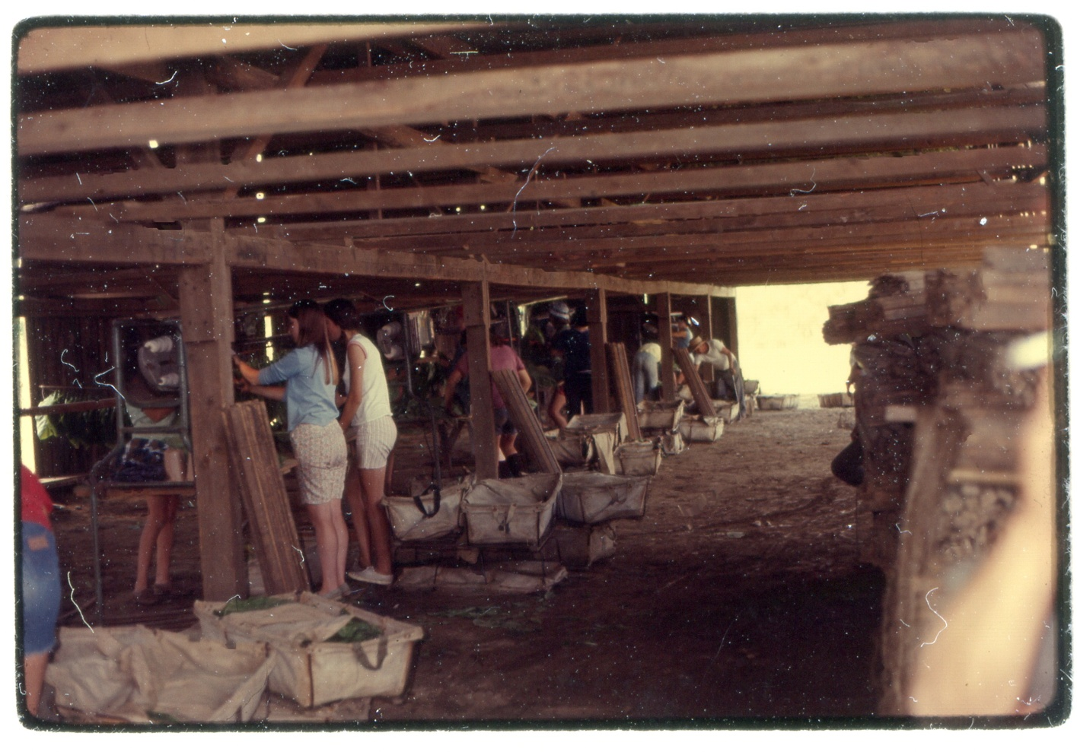
Working inside the dark, murky barns. Photo by Joe Baceski.
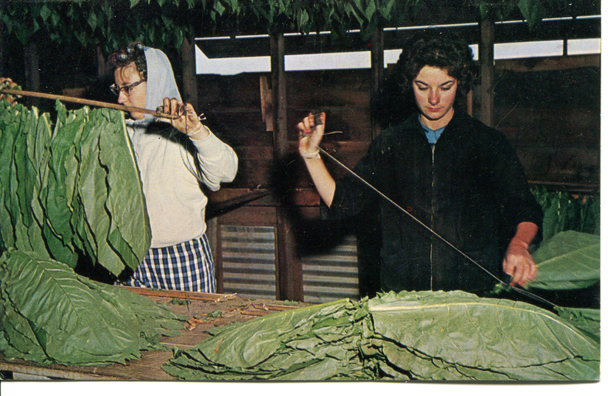
Our fingers were always taped up from getting sores – both from the twisting of string around the plants when working outside and from "sewing" the leaves onto laths inside the barns. We didn’t worry about infections or inhaling the smell of tobacco and dirt. It was fun being there flirting around with the boys! We relished looking for the boys and laughing with them at lunch! The boys were what it was all about! Plus, my girlfriends from school were also employed in tobacco. So, we saw our friends every day and gossiped at home afterwards about the boys and all that happened. We met new girl and boy friends of our own age, more so than in any other place we could have worked. But at 14, as I said previously, you really couldn't get a job doing anything else other than babysitting! In the summertime in Hatfield at that time, there weren’t swimming classes or any special classes for taking the SATs!
Girls sewing leaves onto laths. Tobacco postcard donated by Joe Baceski.

I think working in tobacco instilled a good work ethic in me. I had to be up functioning and ready to go to work at a certain time every day. I had to listen to discover how to do things properly. I learned to respect certain adults and maybe some others not so much. I was young. I was enthusiastic and I wanted to have a great time and I did!

I worked at the Billy Wilkes farm for two mostly amusing but hardworking summers. Once I turned 16 in March, I got a job at Bradley's Department Store in Northampton on King Street during the summers and part-time during the school year working in the lingerie department. I got paid more than I would have in tobacco, the store was clean and smelled pleasant; we could wear nice clothes, and no tape was needed for our fingers! At Christmas time, the older men (probably aged 30!) would always want me to hold up the bras or sexy lingerie on sale to envision how they would look on their wives – too funny! But that’s another story!

Life After Tobacco
I graduated from UMass/Amherst in 1967 with a BA degree. After commuting one year with Mike Cahill (also from Hatfield), I lived in the dormitories for two years and then lived in the Kappa Alpha Theta sorority house my last year of college. After graduation, I went to Washington, DC, and worked for two years at what is now called the Department of Health and Human Services. I then spent an exciting experience that following summer traveling in Europe through Italy, France, Germany, Greece, England and Switzerland.
Upon returning, I lived in Boston and then Andover working for Tallman Eye Associates, Temple Emanuel Nursery School, and 19 years at Phillips Academy. During that time, I was married for 47 years to Michael Fitzgerald. We had two children, Laura, who is married and has four sons, and Sean, who is married and lives in England. My husband and I lived in Andover for 37 years raising our family. Once I retired in 2013, we moved to Osterville, MA, and enjoyed Cape living until 2020, when Michael passed away. In 2021, I sold our home and moved to Salem, NH, where I live in the beautiful Hanover Tuscan Apartments in the Tuscan Market area. I’ve had a very happy, healthy and fulfilling life thus far and hope to continue that for many more years!

